**PROBLEM STATEMENT**

**KPI’S REQUIREMENT**

We need to analyze key indicators for our pizza sales data to gains Insignts into our business performance. Specifically, we want to calculate the following metrics

1. **Total Revenue**: The sum of total price of all pizza orders
2. **Average Order Value**: The average amount spent per order, calculated by dividing the total revenue by the total number of records
3. **Total pizza Sold**: The sum of the quantities of all pizzas sold
4. **Total Orders**: The total number of orders placed
5. **Average Pizzas Per order**: The average number of pizzas sold per order, calculated by dividing the total number of pizzas sold by the total number of orders

She wants to visualize KPI indicators from data that she provides us in order to gain insights into our business performance.

**CHARTS REQUIREMENT**

We would like to visualize various aspects of our pizza sales to gain insights and understand key trends. We have identified the following requirements for creating charts:

1. **Daily Trend for Total Orders:**

Create a bar chart that displays the daily trend of Total orders over a specific time period. This chart will help us identify any patterns or fluctuations in order volumes on a daily basis

1. **Hourly Trend for Total Orders:**

Create a line chart that illustrates the hourly trends of total order throughout the day. This chart will allow us to identify peak hours or periods of high order activity.

1. **Percentage of Sales by Pizza Category:**

Create a pie chart that shows the distribution of Sales across different pizza categories. This chart will provide insights into the popularity of various categories and their contribution to overall sales.

1. **Percentage of Sales by Pizza Size:**

Generate a pie chart that represents the percentage of sales attributed to different pizza sizes. This chart will help us understand customers preferences for pizza sizes and their impact on sales.

1. **Total Pizzas Sold by Pizza category:**

Create a funnel chart that present the total number of pizzas sold for each pizza category. This chart will allow us to compare the sales performance of different pizza categories.

1. **Top 5 Best Sellers by total Pizzas Sold:**

Create a bar chart highlighting the top 5 best-selling pizzas based on the total number of pizzas sold. This chart helps us identify the most popular pizza options.

1. **Bottom 5 Worst Sellers by Total Pizzas Sold:**

Create a bar chart showcasing the bottom 5 worst-selling pizzas based on the total number of pizzas sold. This chart will enable us to identify underperforming or less popular pizza options.

**SQL Server Name**: SPAAK\SQLEXPRESS01

**SQL QUERY**

**Total Revenue**

select sum(total_price) AS Total_revenue from pizza_sales;

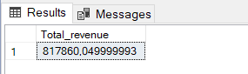

**Average Order Value**

select ROUND(sum(total_price)/count(DISTINCT(order_id)),2) AS Avg_order_value from pizza_sales;

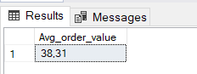

**Total pizza Sold**

select sum(quantity) AS Total_pizza_sold from pizza_sales;

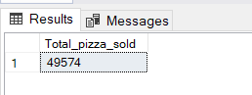

**Total Orders**

SELECT COUNT(DISTINCT order_id) AS Total_orders from pizza_sales;

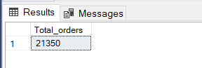

**Average Pizzas Per order**

SELECT CAST( CAST(SUM(quantity) AS DECIMAL(10,2))/

CAST(COUNT(DISTINCT order_id) AS DECIMAL(10,2)) AS DECIMAL(10,2)) AS Avg_pizza_sold_order

from pizza_sales;

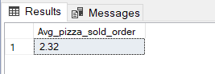

**Daily Trends of Total Order**

SELECT DATENAME(DW, order_date) as order_days, COUNT(DISTINCT order_id) as Total_order

FROM pizza_sales

GROUP BY DATENAME(DW, order_date)

order by Total_order desc;

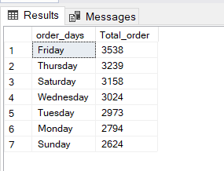

**Total pizza sold by Category**

SELECT pizza_category, SUM(quantity) AS Total_sold

from pizza_sales

Group by pizza_category

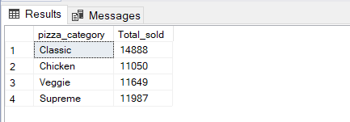

**Hourly Trends of Total Order**

SELECT DATEPART(HOUR, order_time) as order_hours, COUNT(DISTINCT order_id) as Total_orderFROM pizza_sales

GROUP BY DATEPART(HOUR, order_time)

order by DATEPART(HOUR, order_time)

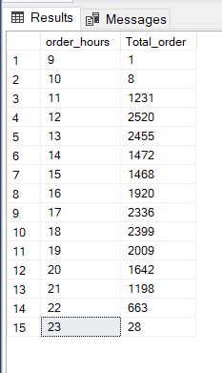

**Percentage of Sales by Pizza Category filter by month**

SELECT pizza_category,

SUM(total_price) * 100 / (SELECT SUM(total_price) from pizza_sales) AS Sales_percentage,

SUM(total_price) AS Total_sales

FROM pizza_sales

WHERE MONTH(order_date) = 2

GROUP BY pizza_category

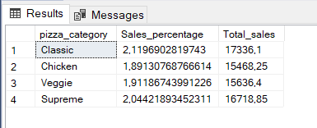

**Percentage of Sales by Pizza size**

SELECT pizza_size,

SUM(total_price)*100 / (SELECT SUM(total_price) from pizza_sales) AS Total_Sales,

SUM(total_price) AS Total_Sales

from pizza_sales

Group by pizza_size;

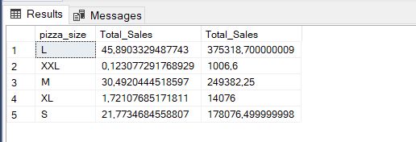

**Top 5 Best Sellers by total Pizzas Sold**

SELECT TOP 5 pizza_name, SUM(quantity) AS Total_number

from pizza_sales

Group by pizza_name

order by SUM(quantity) DESC

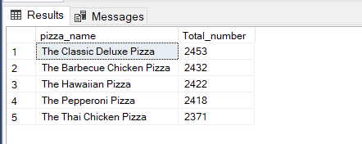

**Bottom 5 Worst Sellers by Total Pizzas Sold**

SELECT TOP 5 pizza_name, SUM(quantity) AS Total_number

from pizza_sales

Group by pizza_name

order by SUM(quantity) ASC

